**Adviti Pvt. Ltd.: HR Analytics Project Report**

**Introduction**

This report includes the analysis of two key aspects of Human Resource Management of Adviti Private Limited:

1. Attrition of the Employees
2. Effectiveness of Training Program

The analysis is purely based on HR data that includes various metrics like Years of Service, Salary, Promotion, Training hours, etc.

**Objectives**

This report centered below two major objectives:

1. To identify and examine the factors influencing Employee Attrition.
2. To evaluate the current training program and enhancing the effectiveness leading to improvement of employee’s performance.

**Data Cleaning and Preparation**

The given dataset contained uneven entries with some missing data. Following actions had been taken to prepare the data:

1. For columns like Gender and Position, the data entries have been updated to make dataset more readable.

Following changes has been done:

1. Replaced ‘Female’ entry with ‘F’ and ‘Male’ entry with ‘M’.
2. Grouped positions like ‘AccountExecutive’, ‘AccountExec.’, ‘Account Exec.’ together as ‘Account Executive’.
3. Grouped positions like ‘DataAnalyst’, ‘Analyst ‘together as

‘Data Analyst’.

1. Grouped positions like ‘Creator’ together as ‘Content Creator’.
2. To understand and analyse data more clearly, categorized data like Age, Years_of_Service, etc. into different group. This helped to find patterns from data rather than going through each individual entry.
3. Age column converted into Age_Group as

’20-30’, ’31-40’, ’41-50’ based on range of age.

1. Years_of_Service column converted into Experience_Category as

‘0-2 Years’, ‘2-5 Years’, ‘5-10 Years’, '10-15 Years', '15+ Years'.

1. The different attributes contributing to the satisfaction of employees had been analysed and created a new column as Employee_Satisfaction_Score for overall satisfaction of the employee.

This column is evaluated using following formula: (JobSatisfaction_PeerRelationship + JobSatisfaction_WorkLifeBalance +

JobSatisfaction_Compensation + JobSatisfaction_Management +

JobSatisfaction_JobSecurity) / 5 * 100

1. The different attributes contributing to the benefits of employees had been analysed and created a new column as Employee_Benefit_Score for overall benefits of the employees.

This column is evaluated using following formula: (EmployeeBenefit_HealthInsurance + EmployeeBenefit_PaidLeave + EmployeeBenefit_RetirementPlan + EmployeeBenefit_GymMembership + EmployeeBenefit_ChildCare) / 5 * 100

**Analysis and Insights**

* **Factors Influencing Employee Attrition**

1. Total Attrition Rate:



* This shows attrition rate is higher among the organisation as the number of people leaving is more than the number of active employees.

1. Gender wise Attrition Rate:



* This shows that attrition rate is higher among Male Employees.

1. Gender vs Employee satisfaction score wise Attrition Rate:



* This implies that Male employees are less satisfied with different aspects of job satisfaction as compared to Female.

1. Department wise Attrition rate:

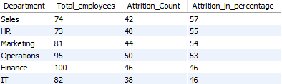



* Sales department has highest attrition among all the departments and those who are leaving have mentioned less satisfaction towards company’s job satisfaction aspects.
* Finance and IT department has comparatively less attrition than the other departments.

1. Position wise Attrition Rate:

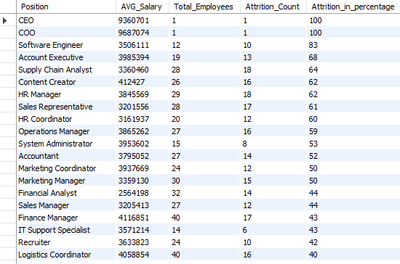

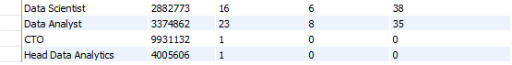

* From the data, it looks like CEO and COO has left the organisation impacting the increasing attrition rate among employees.
* Software Engineer has highest attrition rate around 83%. Below that Account Executive has high attrition rate of 68%.

1. Age vs Years of service vs Employee Satisfaction:

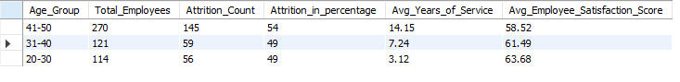

* For the age group between 41 to 50 as the years of experience is more, employee satisfaction score seems to be less. In order to decrease the attrition rate among senior employees, organisation needs to focus on the satisfaction factors.

1. Work_Hours wise Attrition Rate:

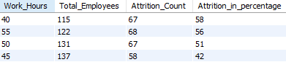

* Employees with least and most working hours shows the maximum attrition rate.

1. Distance vs Attrition Rate:

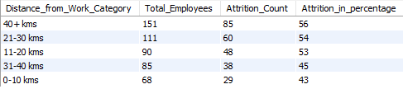

* This shows that distance from the company affects employee’s attrition as employees living at a distance of 40+ kms are leaving the company.

1. Promotion vs Attrition Rate:



* This count shows that employees who hasn’t been promoted are most likely leaving the organisation.

1. Salary wise Attrition Rate:

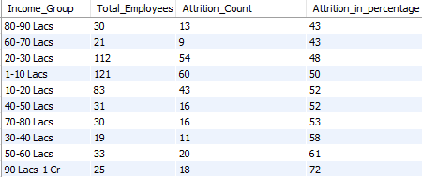

* Employees having maximum salary are leaving the organisation in a higher percentage.

1. Years of Service wise Attrition Rate:

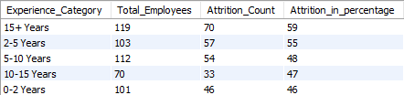

* These numbers suggests that employees with 15+ years of service are leaving the most. This defines that senior and well experienced employees are leaving that might affect the performance and productivity of the organisation.

1. Performance Rating wise Attrition Rate:

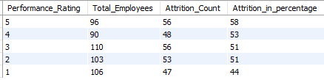

* This data clearly shows that as the rating increases among the employees the attrition rate also increases suggesting that employee might be looking for a better opportunity as their performance gets better.

1. Performance Rating vs Promotion wise Attrition Rate:

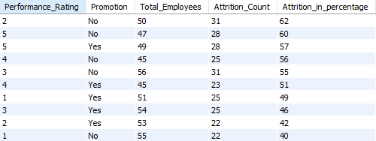

* This comparison clearly shows that employees with higher performance rating who are promoted or not, more likely leaving the company for a better opportunity.
* Also, employees with performance rating 3 or 4 who are not being promoted are typically leaving.
* **Optimize Employee Training Program:**

1. Training Hours Vs Attrition Rate:



* This data gives a very evident information that increase in hours of ongoing training program leading the attrition among the employees.

1. Performance Rating Vs Training Hours:

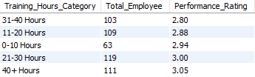

* Employee getting 40+ hours of training have good performance rating indicating that the given training is increasing employee’s work efficiency.

3. Employer Satisfaction Score Vs Training Hours Vs Attrition Rate:

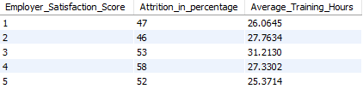

* Here we can see that employees having satisfaction score of 3 have maximum training hours with bit of higher attrition rate. While employees with lower satisfaction score have comparatively less training hours.

**Final Recommendations:**

* Organization must set up one-on-one call with CEO and COO as their absence might be increasing overall attrition rate and try to retain their position by providing a good benefit.
* Male employees have higher attrition rate than the female employees which can be maintained by focusing different factors like working hours, employee benefits, etc.
* To decrease the attrition in sales department, organization can conduct survey and ask for feedback on a different company’s policy like work life balance, peer relationships among themselves.
* Employees with maximum years of service have high attrition rate which might affect the growth of the company. In order to retain such employees company can provide good insurance plan, child care plan or retirement plan.
* Organization should provide travel facility to the employees who live at a significantly large distance.
* Employees should get promoted or should get a hike in the salary on the basis of their overall performance.
* It is quite visible that employees with higher salary are leaving. This indicates that there is another problem among those employees like career growth, job satisfaction, etc.
* Employees with high performance rating are leaving. Organization can ensure them good career growth with better opportunity.
* Employees having more training hours are leaving. Organization should more focus on quality and effectiveness of program.
* Investing good amount of training hours is leading to a better performance of employees.